Lab 4

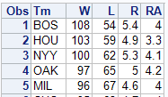

1. Explanatory = Pythagorean Percentage and Response = Winning Percentage
2. 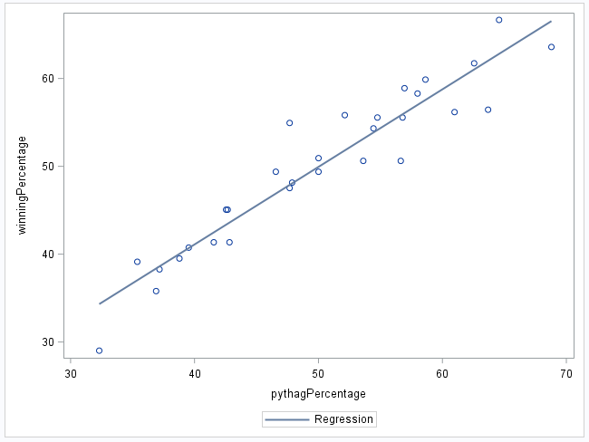
   1. 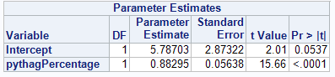
   2. Ŷ = 5.78 + 0.8x
3. SEA
   1. SEA has most positive residual
   2. To calculate the residual, you can do the win percentage minus the predicted value.
   3. LAD has most negative residual
4. 